**Automation scrapping of SWE_H1 Yearly Dataset (25yrs approx):**

*Code Logic 1: Written codebase from scratch for https request and response and saving it in cdf format for each year.*

*Code Logic 2: Rest request provided by Nasa cadaweb and fetching response.*

**Code Logic 1 output structure:**

1. Validating how many dataset are there in a year.

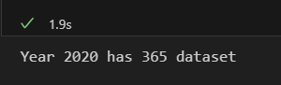

1. Downloading all 365 cdf dataset using our codebase which take approx [ 2 -2.5 min for each year all 365 or less cdf Files] :

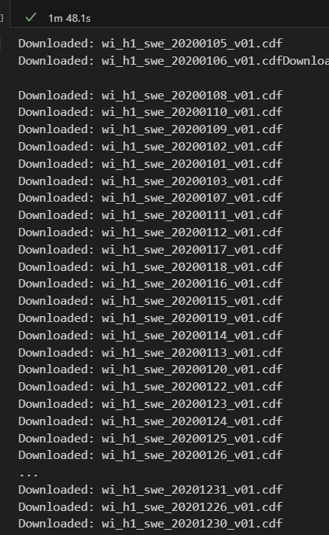

1. The Folder with all data of trial year 2020:

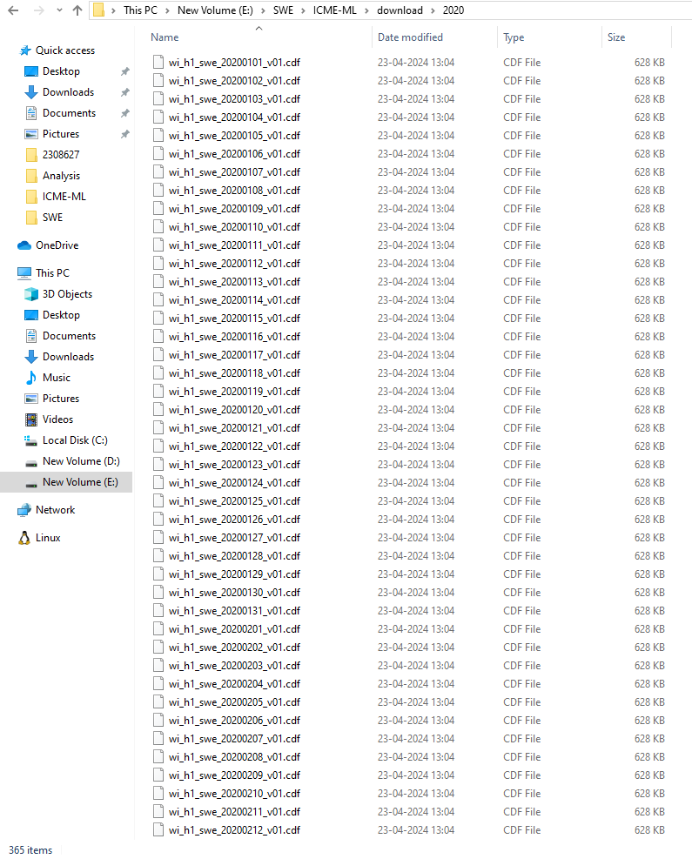

Note for logic1:

1. We have code base for combining 3 cdf with each other with logic 1 because its download single day file one by one for complete year.

***Code Logic 2: Rest request from Nasa cadaweb and fetching response.***

* Same output structure
* It has default option for range of date so combined cdf are given by rest api itself. No need of another cdf combines logic code from scratch like logic 1.

Note for logic2:

1. Slow than logic 1.
2. Chances of minor more request failures compare to logic1.